ADMISSION

INFORMATION PACK

- Admission Form – to be completed and returned with copy of most recent school report (if applicable)

- School Uniform Policy

- Photography and the use of images

- Youth Service Support Provider Access Policy

- Benefits that may apply to you

- ADMISSION FORM to be completed by the parent/carer and pupil

Application for (please tick)
King David High School | Yavneh Yeshiva High School | Yavneh Girls High School
King David High School Sixth  Form | King David High School – Yavneh Yeshiva Sixth Form | King David High School – Yavneh Girls Sixth Form

Surname: |  |  |  | Legal Surname:
Forename: |  |  |  | Middle name:
Chosen name: |  |  |  | Gender at birth:
Date of Birth: |  |  |  | Gender Identity:
Address:
Post Code:

Please give details of all persons who have parental responsibility and anyone else you wish to be contacted in an emergency. Place them in the order that you wish for them to be contacted in an emergency.
Priority | Name/Relationship | Home Address
 |  | Main Tel:  Mobile: | Email:
Priority | Name/Relationship | Home Address
 |  | Main Tel:  Mobile: | Email:
Priority | Name/Relationship | Home Address
 |  | Main Tel:  Mobile: | Email:

Present/Previous School:
Name of school:

If coming from abroad give details of any previous UK school:

Siblings: |  | Attending King David High Yes/No If no School attending

Are you a member of or do you attend a Synagogue: YES/NO. If YES please provide following details:
Name of Synagogue (if applicable):

Attendance since:

How often do you attend Synagogue:

Dietary Needs:
Paramedial Support eg: Occupational Therapy/Physiotherapy/Speech Therapy:

Any additional information:

Medical Practice | Address | Telephone Number

Medical Note(s)

Medical Condition(s)

Ethnicity: | Religion
Home Language: | First Language
English as Additional Language: YES/NO

Additional Information if YES please provide details:
Service Child – YES/NO

Is on Free School Meals if yes which authority: YES/NO

Has previously been on Free School Meals: YES/NO

Special Educational needs: YES/NO

Asylum Status: YES/NO

Traveller Status: YES/NO

In Care: YES/NO

Is a Young Carer: YES/NO

Disabilities: YES/NO

Consent for Pupil and Parent/Carer to complete.

- I agree to support and uphold the School Uniform Policy (Uniform Policy attached)

Parent Signature…………………….…………………………. Pupil Signature…………………………………………..

Name in capitals …………………………………………….... Name in capitals …………………………………………

- Parent/Carer/Pupil consent for photography and the use of images during the course of the school year (information attached):

I DO I DO NOT (delete as appropriate) give consent:

Parent Signature…………………….…………………………. Pupil Signature…………………………………………..

Name in capitals …………………………………………….... Name in capitals …………………………………………

- I will support the religious ethos of the school:

Parent Signature…………………….…………………………. Pupil Signature…………………………………………..

Name in capitals …………………………………………….... Name in capitals …………………………………………

- I agree to abide by the school rules and the behaviour policy (document in welcome pack – Information/Guides No 1 Student Guide):

Parent Signature…………………….…………………………. Pupil Signature…………………………………………..

Name in capitals …………………………………………….... Name in capitals …………………………………………

- I consent to the Youth Service Support Provider Access Policy (information attached):

I DO I DO NOT (delete as appropriate) give consent:

Parent Signature…………………….…………………………. Pupil Signature…………………………………………..

Name in capitals …………………………………………….... Name in capitals …………………………………………

Data Protection Act 1998: The school is registered under the Data Protection Act for holding personal data. The school has a duty to protect this information and to keep it up to date. The school is required to share some of the data with the Local Authority and with the DfE.
Parent/Carer Signature: | Date:

For official use only:

Member of staff conducting admission interview complete the following:

Start date: Year Group: Reg Group:

Class sets:

Option choices for Y10, Y11, Y12 or Y13

Copy of GCSE Certificates required for Y12 or Y13 students: Copied YES/NO To follow (passed to, to follow up ………………. )

UCI Number for 6th form student:

EAL document below to be completed if applicable and forwarded to SEND/EAL Co-Ordinator and Exams Officer

Additional Information:

EAL - only if applicable - Staff please ask parents the following questions and circle either YES or No:
EAL Pupil application form - awarding extra time during examinations

- The candidate’s first language is not English, Irish or Welsh: YES/NO

- the candidate entered the United Kingdom within three years of the examination(s) with no prior knowledge of the English Language: YES/NO

- English is not one of the languages spoken in the family home: YES/NO

- prior to their arrival in the United Kingdom the candidate was not educated in an International school where some or the entire curriculum was delivered in English: YES/NO

- prior to their arrival in the United Kingdom the candidate was not prepared for or entered for IGCSE qualification where the question papers were set in English: YES/NO

- prior to their arrival in the United Kingdom the candidate was not prepared in English for other qualifications, eg IELTS qualifications, Preliminary English Tests: YES/NO

- the candidate has to refer to the bilingual translation dictionary so often that examination time is used for this purpose, delaying the answering of questions: YES/NO

- the provision of 10% extra time reflects the candidate’s usual way of working with the dictionary. (A definition of normal way of working is provided within Chaper 4, paragraph 4.2.5.) YES/NO

EAL Additional Information:

2. School Uniform Policy
The King David High School believes that our school uniform:
- Is practical and smart
- Promotes a sense of pride in the school
- Helps create a sense of community and belonging towards the school
- Promotes a sense of equality amongst peers
- Helps identify and represent the school
All pupils are required to wear the standard uniform and must conform to the following rules. Sanctions may be applied for failure to meet The King David High School standard.
All pupils
Please contact l.rose@kdhigh.co.uk if you need help to fund the uniform
Item | KDHS Standard | Not allowed
A navy blue blazer with the school badge. | Worn at all times to and from the school.  Worn at all times around the school.  School-awarded badges only | Taking it off without permission in the classroom  Must not be worn around the waist  Non-school badges/stickers
Navy blue V-necked knitted jumpers | Optional | Must not be worn around the waist. Sweatshirts are not permitted.
Black shoes in a flat sensible style | Plain black polishable only  Waterproof (not fabric)  Flat  Black sole | No contrasting colours eg. logos/ stripes/soles etc.  Patterned shoes  Shoes with heels  Boots  Pumps, sandals or canvas shoes
Boys uniform | Girls uniform
- School tie – to be worn to the neck at the correct length at all times.  - Plain grey school trousers to be worn at the waist.  - White school shirt  - Plain, dark coloured socks  - Kippot  - Tephillin (for assemblies) is encouraged following Bar Mitzvah | - Skirts must be loose fitting, navy blue with tick pleats front and back, to be worn at knee length at all times. (Skirts only available from School stockists).  - Navy blue stripe open neck blouse with reveres.  - Ankle socks or tights, either must be plain; navy blue or black
Boys’ P.E. | Girls’ P.E.
- Football boots & shin pads  - Indoor trainers (with soles which do not mark)  - Outdoor trainers  - Navy football socks  - Plain white polo shirt  - Navy shorts  - Badged navy shirt  - Navy blue swimming shorts  - Goggles (optional)  - Towel & toiletries. Spray deodorants are not allowed (shower facilities available) | - Indoor trainers (with soles which do not mark)  - Outdoor trainers  - White socks  - Plain white polo shirt  - Navy blue skorts/navy blue shorts  - School navy blue sports leggings (optional) only available from School stockists  - Plain navy blue swimming costume  - School swimming cap  - School Tracksuit/Sweatshirt (optional)  - Goggles (optional)  - Towel & toiletries. Spray deodorants are not allowed (shower facilities available)

Appearance
Sanctions may be applied for failure to meet The King David High School standard
Item | KDHS Standard | Not allowed
All uniform worn neatly and correctly | Clean and in good condition  shirts must be tucked into waistbands  sleeves rolled down  top buttons must be kept fastened  Skirts at the correct length. | Jumpers with frayed sleeves  Trousers with ripped hems.  Rolled-up skirts
Hairstyles | Natural in colour  Smart, neat and tidy | Extreme styles including:  Coloured/shaved patterns in hair or eyebrows  ‘Tip dying’ or unnatural or extreme coloured hair  Unnaturally coloured braids, accessories or extensions
Makeup | Completely free of visible make-up | Any type of visible make-up including;  Fake tan  Make- up bag/items  False eyelashes,
Nails | Natural, plain, acceptable length | Coloured nail varnish  False nails  Long Nails
Jewellery | Wristwatch only  Earring– single plain stud in lower lobe | Hooped, ’bling’ or dropped earrings  Facial piercings including nose piercings  Rings, bracelets and necklaces.
Equipment for School
All pupils must bring the following items to school
Item | KDHS Standard | Not allowed
Bag | All students are expected to carry their possessions in a suitable bag that fully closes  Sturdy and large enough to carry all school equipment and books. | Handbag style  Small over the shoulder fashion bags  Carrying belongings in blazer pockets
Pencil case | A number of Black and/or blue pens  A green pen  A number of pencils  Ruler  Eraser  Scientific Calculator | Correction fluid  Laser pens

School Outfitters:
Monkhouse School - www.monkhouse.com
Mill Gate Shopping Centre, 86 The Rock, Bury 0161 476 7216
4-8 The Precinct, Cheadle Hulme SK8 5BE 0161 476 7216
PT’s Schoolwear - www.pts-schoolwear.co.uk
Market Hall, 14, Market Parade, Bury 0161 761 1365
7 New Road, Radcliffe M26 1LS 0161 723 0991

Uniform policy home school agreement
Pupils, who do not attend school in the correct uniform, will be spoken to by staff. School will be considerate and attempt to establish why a pupil may not be able to attend in the correct uniform. A pupil may be offered a replacement item to borrow if one is available; or, pupils may be given an opportunity to adhere to the correct uniform within a timeframe. However, in certain circumstances pupils may be sent home to correct their uniform or parents asked to bring in uniform items.
If a pupil repeatedly chooses not to wear the appropriate uniform and/or refuses to follow a reasonable request, such as borrowing uniform, then we will issue a consequence in line with our behaviour policy and expectations.
Having accepted a place at The King David High School, parents and carers are supporting us in reinforcing our values and high expectations.
Shoe examples:
Not Permitted
Permitted
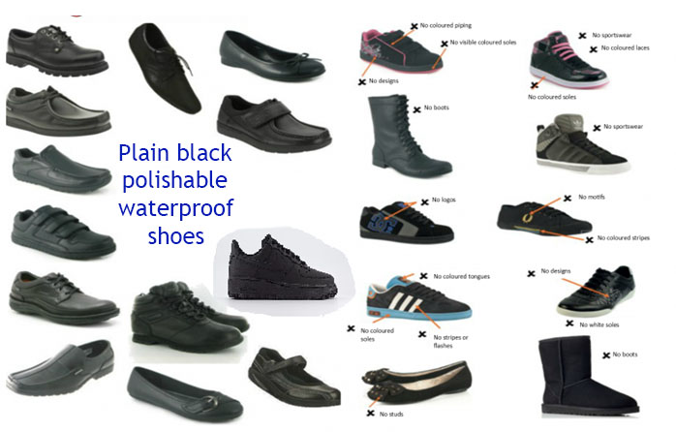

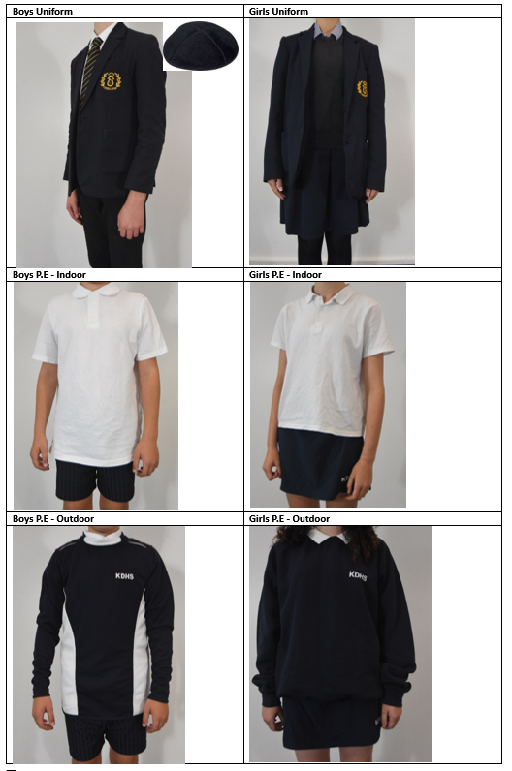

3. Photography and the use of images
During the school year there may be opportunities to publicise some of the activities that your child is involved in. This may well involve filming or photographing children for use in the local media. As a school, we welcome these opportunities and hope that you do too. There may also be occasions when we arrange photography for our own purposes, such as displays and brochures.

Photography or filming will only take place with the permission of the head teacher, and under the supervision of a teacher. When filming or photography is carried out by the news media, pupils will only be named if there is a particular reason to do so and a home address will never be given out.

There may be other circumstances, falling outside the normal day to day activities of the school, in which pictures of children are requested. The school recognises that in such circumstances specific consent from parent or carer will be required before the school can permit photography or filming of children.

We believe that positive publicity benefits all involved with the school. Nevertheless, we will not involve your child without your consent.

4. Youth Service Support Provider Access Policy

This policy statement sets out the school’s arrangements for managing the access of providers to pupils at King David High School for the purpose of giving them information about the provider’s education or training offer.

This complies with the school’s legal obligations under Sections 42A,42B, 45 and 45A of the Education Act 1997. Section 72 of the Education and Skills Act 2008 • Schedule 4 (15) of the School Information (England) Regulations 2008.

Pupil Entitlement

All pupils in years 7-11 are entitled:

- to find out about technical education qualifications and apprenticeships opportunities, as part of a careers programme which provides information on the full range of education and training options available at each transition point;
- to hear from a range of local providers about the opportunities they offer, including technical education and apprenticeships – through options events, assemblies and group discussions and taster events;
- to understand how to make applications for the full range of academic and technical courses.

Opportunities for access

A number of events, integrated into the school careers programme, will offer providers an opportunity to come into school to speak to pupils and/or their parents/carers:

Careers Lessons
Parents Evening
Industry specific workshops
Careers Fair
Inspirational speakers
Careers Lessons Industry specific assemblies
Option Assemblies
Mock interviews
Work experience opportunities
Apprenticeship
Study skills sessions

Premises and facilities

The school will make the main hall, classrooms or private meeting rooms available for discussions between the provider and students, as appropriate to the activity. The school will also make available equipment to support provider presentations. This will all be discussed and agreed in advance of the visit with the Careers Leader or a member of their team.

Providers are welcome to leave a copy of their prospectus or other relevant course literature in the school library, which is managed by the school librarian. This is available to all pupils in the school library.

5. Benefits
We want to make sure that we are providing your child with the best education and support we can. Healthy school food has obvious health benefits and can help pupils establish healthy habits for life. Healthy school food can also help to improve pupils’ readiness to learn.
Families who receive certain benefits may be eligible for free school meals. Your child is eligible for free school meals if you’re in receipt of one of the following benefits:
- Universal Credit with an annual net earned income of no more than £7,400
- Income Support
- Income-based Jobseeker’s Allowance
- Income-related Employment and Support Allowance
- Support under Part 6 of the Immigration and Asylum Act 1999
- The guaranteed element of Pension Credit
- Working Tax Credit run-on (paid for the four weeks after you stop qualifying for Working Tax Credit)
- Child Tax Credit (with no Working Tax Credit) with an annual income of no more than £16,190
Registering for free meals could also raise an extra £900 for your child’s secondary school, to fund valuable support like extra tuition, additional teaching staff or after school activities.

This additional money is available from central government for every child whose parent is receiving one of the benefits listed above.

To check if your child is eligible, we need information about you and your child. Please complete this form and return to the school office.

About your child/children
Child’s Last Name | Child’s First Name | Child’s Date of Birth |  |  | Name of School
 |  | D D | M M | Y Y Y Y
 |  | D D | M M | Y Y Y Y
 |  | D D | M M | Y Y Y Y

Parent/carer details
 | Parent/Guardian 1 |  |  |  |  |  |  |  |  |  |  |  |  |  |  |  |  |  |  |  | Parent/Guardian 2
Last name
First Name
Date of Birth | D D |  |  |  |  |  | M M |  |  |  |  |  | Y Y Y Y |  |  |  |  |  |  |  | D D |  |  |  |  |  | M M |  |  |  |  |  |  | Y Y Y Y
National Insurance Number*
National Asylum Support Service (NASS) Number* |  |  |  | / |  |  |  |  |  |  | / |  |  |  |  |  |  |  |  |  |  |  |  | / |  |  |  |  |  |  | /
Daytime Telephone Number
Mobile Number
Address | Postcode: |  |  |  |  |  |  |  |  |  |  |  |  |  |  |  |  |  |  |  | Postcode:

Family income and benefit details

If you receive any of the benefits listed below, please place an X in this box.
- Income Support
- Income-based Jobseekers Allowance
- Income-related Employment and Support Allowance
- Support from NASS under part 6 of the Immigration and Asylum Act 1999
- the guarantee element of Pension Credit
- Child Tax Credit (with no Working Tax Credit)
- Working Tax Credit run-on
- Universal Credit
Universal Credit
If you are in receipt of Universal Credit, is your net earned family income over £7,400 per year? (Please place an X in the appropriate box).
Your net earned income is your household income after taxes and deductions. It does not include income through Universal Credit or other benefits that you may receive.
Yes No Unsure

Child Tax Credit
If you are in receipt of Child Tax Credit, is your joint gross annual income over £16,190 per year? (Please place an X in the appropriate box).
Your joint gross income is your household income before taxes are

Yes No Unsure
If you’re not sure whether you receive one of the listed benefits, or what your household income is, but you would still like us to check whether your child is eligible for free school meals, please place an X in this box.
Declaration

The information I have given on this form is complete and accurate. I understand that my personal information is held securely and will be used only for local authority purposes. I agree to the local authority using this information to process my application for free school meals. I also agree to notify the local authority in writing of any change in my family’s financial circumstances as set out in this form.

Signature of parent/carer: ………………………………………………………….
Date:……………………….

Thank you for completing this form and helping to make sure your child’s school is as well funded as possible.

How the information in this form will be used

The information you provide in this form will be used by the council to confirm receipt of one of the listed welfare benefits. Once this is confirmed, this helps to decide how much money your child’s school will receive each year.
The information will also be used in relation to pupils in year 3 or above to decide whether they are eligible for free school meals.

You only need to complete this form once and it will last for the duration of your child’s time at their current school. You should contact the school or local authority if you have a change in financial circumstances.

We are committed to ensuring that the personal and sensitive information that we hold about you is protected and kept safe and secure, and we have measures in place to prevent the loss, misuse or alteration of your personal information. We will use the information you provide to assess entitlement to free school meals. The information may also be shared with other Council departments to offer benefits and services.

