WELCOME PACK
For Students and Parents

Policies
- Uniform and Personal Appearance Policy
- Acceptable Internet and Electronic Communication Policy
- Anti-Bullying Policy
- Medicines Policy
- Marking Policy

Contributions

1. Parental contributions
2. ParentPay
3. School fund
4. Pupil Lockers
5. Bus service South Manchester
6. Parental security rota
7. Benefits

Information/Guides

1. Student Guide
2. Student emails
3. Edulink one
4. What to do if
5. Instrumental and vocal tuition
6. Holiday list
7. English department transition booklet

POLICIES
1. Uniform and Personal Appearance Policy
The King David High School believes that our school uniform:
- Is practical and smart
- Promotes a sense of pride in the school
- Helps create a sense of community and belonging towards the school
- Promotes a sense of equality amongst peers
- Helps identify and represent the school
All pupils are required to wear the standard uniform and must conform to the following rules. Sanctions may be applied for failure to meet The King David High School standard.
All pupils
Please contact l.rose@kdhigh.co.uk if you need help to fund the uniform
Item | KDHS Standard | Not allowed
A navy blue blazer with the school badge. | Worn at all times to and from the school.  Worn at all times around the school.  School-awarded badges only | Taking it off without permission in the classroom  Must not be worn around the waist  Non-school badges/stickers
Navy blue V-necked knitted jumpers | Optional | Must not be worn around the waist. Sweatshirts are not permitted.
Black shoes in a flat sensible style | Plain black polishable only  Waterproof (not fabric)  Flat  Black sole | No contrasting colours eg. logos/ stripes/soles etc.  Patterned shoes  Shoes with heels  Boots  Pumps, sandals or canvas shoes
Boys uniform | Girls uniform
- School tie – to be worn to the neck at the correct length at all times.  - Plain grey school trousers to be worn at the waist.  - White school shirt  - Plain, dark coloured socks  - Kippot  - Tephillin (for assemblies) is encouraged following Bar Mitzvah | - Skirts must be loose fitting, navy blue with tick pleats front and back, to be worn at knee length at all times. (Skirts only available from School stockists).  - Navy blue stripe open neck blouse with reveres.  - Ankle socks or tights, either must be plain; navy blue or black
Boys’ P.E. | Girls’ P.E.
- Football boots & shin pads  - Indoor trainers (with soles which do not mark)  - Outdoor trainers  - Navy football socks  - Plain white polo shirt  - Navy shorts  - Badged navy shirt  - Navy blue swimming shorts  - Goggles (optional)  - Towel & toiletries. Spray deodorants are not allowed (shower facilities available) | - Indoor trainers (with soles which do not mark)  - Outdoor trainers  - White socks  - Plain white polo shirt  - Navy blue skorts/navy blue shorts  - School navy blue sports leggings (optional) only available from School stockists  - Plain navy blue swimming costume  - School swimming cap  - School Tracksuit/Sweatshirt (optional)  - Goggles (optional)  - Towel & toiletries. Spray deodorants are not allowed (shower facilities available)

Appearance
Sanctions may be applied for failure to meet The King David High School standard
Item | KDHS Standard | Not allowed
All uniform worn neatly and correctly | Clean and in good condition  shirts must be tucked into waistbands  sleeves rolled down  top buttons must be kept fastened  Skirts at the correct length. | Jumpers with frayed sleeves  Trousers with ripped hems.  Rolled-up skirts
Hairstyles | Natural in colour  Smart, neat and tidy | Extreme styles including:  Coloured/shaved patterns in hair or eyebrows  ‘Tip dying’ or unnatural or extreme coloured hair  Unnaturally coloured braids, accessories or extensions
Makeup | Completely free of visible make-up | Any type of visible make-up including;  Fake tan  Make- up bag/items  False eyelashes,
Nails | Natural, plain, acceptable length | Coloured nail varnish  False nails  Long Nails
Jewellery | Wristwatch only  Earring– single plain stud in lower lobe | Hooped, ’bling’ or dropped earrings  Facial piercings including nose piercings  Rings, bracelets and necklaces.

Equipment for School
All pupils must bring the following items to school
Item | KDHS Standard | Not allowed
Bag | All students are expected to carry their possessions in a suitable bag that fully closes  Sturdy and large enough to carry all school equipment and books. | Handbag style  Small over the shoulder fashion bags  Carrying belongings in blazer pockets
Pencil case | A number of Black and/or blue pens  A green pen  A number of pencils  Ruler  Eraser  Scientific Calculator | Correction fluid  Laser pens

School Outfitters:
Monkhouse School - www.monkhouse.com
Mill Gate Shopping Centre, 86 The Rock, Bury 0161 476 7216
4-8 The Precinct, Cheadle Hulme SK8 5BE 0161 476 7216
PT’s Schoolwear - www.pts-schoolwear.co.uk
Market Hall, 14, Market Parade, Bury 0161 761 1365
7 New Road, Radcliffe M26 1LS 0161 723 0991

Uniform policy home school agreement
Pupils, who do not attend school in the correct uniform, will be spoken to by staff. School will be considerate and attempt to establish why a pupil may not be able to attend in the correct uniform. A pupil may be offered a replacement item to borrow if one is available; or, pupils may be given an opportunity to adhere to the correct uniform within a timeframe. However, in certain circumstances pupils may be sent home to correct their uniform or parents asked to bring in uniform items.
If a pupil repeatedly chooses not to wear the appropriate uniform and/or refuses to follow a reasonable request, such as borrowing uniform, then we will issue a consequence in line with our behaviour policy and expectations.
Having accepted a place at The King David High School, parents and carers are supporting us in reinforcing our values and high expectations.
Shoe examples:
Not Permitted
Permitted
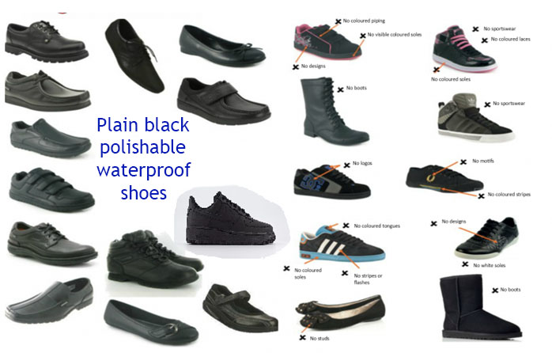

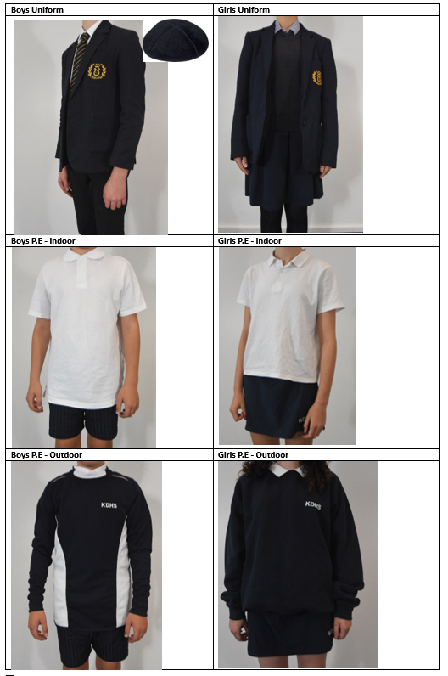

2. Acceptable Internet and Electronic Communication Policy

I understand that use of the Internet and electronic communication is granted to me as a privilege, in return for my acceptance of the agreement. Any misuse on my part may result in loss of that privilege and other sanctions being taken. This also applies to any activity undertaken outside school which contravenes the acceptable use rules of the school.

All online activity will be appropriate to:

- ensure the-Safety and security of the school system
- ensure respect for all members of the community
- maintain the reputation of the school

In particular this means:

- I will only access the school computer system and Internet via my authorised account and password, which I will not make available to others.
- I will ensure that I do not wilfully damage the system by means of malicious code (e.g. virus infections, malware etc.), hacking or physical tampering.
- I will not bring in pen drives from outside school and try to use them on the school system. All students have access to O365 and OneDrive both internally and externally and any work that needs to be completed at home should be saved there.
- I will not wilfully interfere with and/or delete another person’s work files or access other people's files, unless they have been posted onto the Resources area or VLE for this express purpose.
- I will not send or forward messages, publish or create material, which is offensive, hurtful or otherwise upsetting to another person. Nor will I post anonymous messages or forward chain letters. I will immediately report any unpleasant messages sent to me.
- I will not intrude on the privacy of others electronically, whether they are fellow pupils or members of staff, whether this occurs within or external to the school system.
- I will only e-mail people on the school system, or I will obtain permission to e-mail people outside the school system for educational purposes.
- I will not give my full name, my home address or telephone number on an e-mail. I will not use school e-mail facilities to arrange to meet someone outside school hours or use the school e-mail for any personal business.
- Language which I use in electronic communication will be appropriate and suitable, as for all schoolwork.
- I will only use the Internet when it is part of the lesson or is required for my education, e.g. as a research tool.
- I will not use the computers to play on-line games or visit commercial sites during lessons without permission and a clear educational reason to do so.
- I will not use mobile phones, cameras or other electronic devices to take, publish or circulate pictures or videos of anyone without their permission.
- I will respect copyright of all materials.
- I will only access via school’s Wi-fi whilst in school.

In addition, I understand that:

- Use of the network to knowingly access inappropriate materials such as pornographic, racist or offensive material is forbidden and may constitute a criminal offence.
- Guidelines for safe use of the Internet will be followed and I will report any materials or conduct which I feel is unacceptable.
- The school reserves the right to examine or delete any files that may be held on its computer system, to monitor any Internet sites visited and e-mails exchanged and, if necessary to report anything which may constitute a criminal offence.
3. Anti-Bullying Policy

“Treat others as you wish them to treat you”

King David High School recognises that every child has a right to be safe and secure. King David High School is committed to ensuring that each pupil is educated in a safe, caring, and protective environment. It operates a strong pastoral system, which includes Form Tutors, Head of Lower/Upper School, Safeguarding Team, SENCO, Head Teacher and Deputy Head Teacher. This enables pupils and staff to work together in all areas of school life. Issues surrounding bullying, including homophobic and cyber bullying, are discussed and explored in regular Personal Social & Health Education/Citizenship lessons.

The school acknowledges that bullying is a serious issue and has a zero tolerance on bullying and is committed to dealing with each incident in accordance with the following policy:

What is Bullying?

Bullying is behaviour by an individual or group, either physically or emotionally, that is deliberately hurtful and is repeated often over a period of time where it is difficult for victims to defend themselves. Bullying can take many forms (for instance, cyber-bullying via text messages or the internet), and is often motivated by prejudice against particular groups, for example, on grounds of race, religion, gender, sexual orientation, or because a child is adopted or has caring responsibilities. It might be motivated by actual differences between children, or perceived differences. Stopping violence and ensuring immediate physical safety is obviously a school’s first priority but emotional bullying can be more damaging than physical; teachers and schools have to make their own judgements about each specific case.

Bullying may be subtle or overt and may take many forms eg:

Physical: hitting, kicking, punching, taking or damaging belongings and, in extreme cases, it involves serious injuries.

Verbal: name-calling, insulting, repeated teasing, sexist (including homophobic) remarks.

Racist: racial taunts, graffiti, gesture.

Indirect: spreading nasty rumours, excluding from group.

Psychological: a maintained silence can be used to undermine or ostracise.

Technological: by means of information technology eg: text messaging, internet etc.

Cyber-bullying: The rapid development of, and widespread access to, technology has provided a new medium for ‘virtual’ bullying, which can occur in or outside school. Cyber-bullying is a different form of bullying and can happen at all times of the day, with a potentially bigger audience and more accessories as people forward on content at a click. Search powers included in the Education Act 2011 give teachers stronger powers to tackle cyber-bullying by providing a specific power to search for and, if necessary, delete inappropriate images (or files) on electronic devices including mobile phones.
Aims of the policy are to ensure that:

- All pupils feel safe.

- All students receive an education free from bullying.

- The school community will not tolerate any unkind actions or remarks, even if these were not intended to hurt.

- The Pupils feel able to support each other by reporting all instances of bullying and do not support the bully by staying silent.

- The pupils are involved in prevention strategies such as anti-bullying assemblies.

- There should be appropriate support for students who are bullied, for students who are aware of bullying and for staff who are attempting to resolve the issue.

- There should be the opportunity to use restorative justice approaches to resolve bullying issues in the short, medium and long-term.

Staff will respond to any acts of bullying immediately and positively.

At King David High School, we aim to:

- Involve parents to ensure that they are clear that the school does not tolerate
bullying and are aware of the procedures to follow if they believe that their child is being bullied.

- Involve pupils. All pupils understand the school’s approach and are clear about the part they can play to prevent bullying, including when they find themselves as bystanders.
- Regularly evaluate and update our approach to take account of developments in Technology, for instance updating ‘acceptable use’ policies for computers.

- Implement disciplinary sanctions. The consequences of bullying reflect the
seriousness of the incident so that others see that bullying is unacceptable.
- Openly discuss differences between people that could motivate bullying, such as religion, ethnicity, disability, gender or sexuality. Also children with different family situations, such as looked after children or those with caring responsibilities. We will also teach children that using any prejudice based language is unacceptable.

- Provide effective staff training. Anti-bullying policies are most effective when all school staff understand the principles and purpose of the school’s policy, its legal responsibilities regarding bullying, how to resolve problems, and where to seek support. We will seek support where necessary to assist us in understanding the needs of our pupils, including those with special educational needs and/or disability (SEND) and lesbian, gay, bisexual and transgender (LGB&T) pupils.

- Work with the wider community such as the police and children’s services where bullying is particularly serious or persistent and where a criminal offence may have been committed.

- Make it easy for pupils to report bullying so that they are assured that they will be listened to and incidents acted on. Pupils should feel that they can report bullying which may have occurred outside school including cyber-bullying.

- Create an inclusive environment. Schools should create a safe environment where pupils can openly discuss the cause of their bullying without fear of further bullying or discrimination.

- Celebrate success. Celebrating success is an important way of creating a positive school ethos around the issue.

- Use specific organisations or resources for help with particular problems.
Involvement of the Governing Body

The Governing Body of the school will be informed of serious concerns regarding the behaviour of any pupil. The Head teacher or the Designated Safeguarding Lead will raise the matter and, if appropriate, the Governing Body will be kept informed of ongoing developments.

What parents/carers can do:

- Victims of bullying need support from their family, teachers and friends. Sometimes children hide the fact that they are being bullied or they are scared of what the bullies will do if they tell – or are frightened of parents’/carers’ reaction. Children who are bullying others may hide the fact from their parents/carers or present them with a different story. Listen to your child. Trust your child. But remember that s/he may not have told you the full story. Remember that a single incident may not constitute bullying; it may actually be a simple accident, or thoughtlessness and sometimes conclusions are drawn too quickly.
- Tell a member of staff – if your child is being bullied. Parents/Carers, staff and pupils must be prepared to talk so that everybody understands how others feel. Although this is not easy, it is the only effective way to stop bullying.

- If possible, speak to somebody you know and trust eg your child’s Form Tutor, will be able to offer you help and support.
- If you cannot speak to somebody at once, be persistent.
- You may feel impatient with the school. Parents/Carers of bullied children occasionally become angry when schools seem not to punish bullies. There can be very good reasons why schools use other methods of dealing with bullying (it takes time to establish the facts and there must be good evidence against a bully before punishment):

  - Restorative justice may be applied in the first instance as this may result in a swift resolution to the problem

  - A school’s priority is to stop the bullying immediately

  - Whether your child is bullying others or is a victim, try to remember that bullies may need help as well as punishment

  - Bullying is a complex situation to resolve, so try to be patient.

Staff Procedures

- All members of staff should take responsibility for ensuring that all incidences of bullying are reported.

- Pupils can report incidences of bullying to any member of staff. Staff should never promise not to tell anyone, and it is essential that they inform the Safeguarding Team of the incident on the day it was reported to them.

- The Designated Safeguarding Lead/team will then interview the victim and the alleged bully, along with any witnesses.

- Incidents of bullying will be dealt with in accordance with procedures laid down in the school behaviour policy. Parents/Carers may be involved according to the seriousness of the incident.

- It is expected that the policy would normally be successful in resolving the issue. If this is not the case, other measures may be considered, and external agencies may be utilised. If no further improvement in behaviour is secured, or the behaviour of the student is such that all other sanctions are inappropriate, consideration will be given by the Head Teacher to more serious sanctions which may include fixed term or permanent exclusion according to the nature and seriousness of the issues.

4. Medicines Policy

It is the responsibility of parents/carers to:
- inform the school of their child’s medical needs by completing a Healthcare Plan that should be requested from the school office.
- provide any medication in a container clearly labelled with the following:
  - THE CHILD’S NAME
  - NAME OF MEDICINE
  - DOSE AND FREQUENCY OF MEDICATION
  - SPECIAL STORAGE ARRANGEMENTS
  - collect and dispose of any medicines held in school at the end of each term.
  - ensure that medicines have not passed the expiry date.

Administering Medication
  - It is expected that parents/carers will normally administer medication to their children at home. No medication will be administered without prior written permission from the parents/carers, including written medical authority if the medicine needs to be altered (eg crushing of tablets). A Request to Administer Medication Form must be completed. As stated in paragraph 3, staff members are not legally required to administer medicines or to supervise a child when taking medicine. This is a voluntary role.
  - All medicine will normally be administered during breaks and lunchtime. If, for medical reasons, medicine must be taken at other times during the day, arrangements will be made for the medicine to be administered at other prescribed times. Pupils will be told where their medication is kept and who will administer it.
  - Any member of staff, on each occasion, giving medicine to a pupil should check:
- Name of pupil
- Written instructions provided by the parents/carers or doctor
- Prescribed dose
- Expiry date
  - Written permission from the parents/carers will be required for pupils to self-administer medicine(s). This is part of the Request to Administer Medication Form.
Storage

All medicine will be kept in a cabinet in the school Office.

Carrying Medicines

For safety reasons children are not allowed to carry medication (Except inhalers and epi-pens as appropriate.) All other medicines must be handed to the school office.

5. Marking Policy

How is my work marked?

- Your work will be marked regularly by your teachers.

- At least once every 10 hours of teaching your work will be marked formatively. You will receive feedback as to how you can improve.

- You will be expected to read your teacher’s comments and correct your work using a green pen.

- Teachers will also encourage you to use the green pen to reflect on your work, and to highlight any areas that you need to improve on yourself.

- You will be assessed formally at least twice a year in order to attain a summative grade.

- This grade will form part of your tracking, along with an effort grade and a target grade for each subject.

- You will receive reports containing this information at least twice each year; your teachers may also use these reports to comment on your progress, and to give advice for improvement.

These are some of the ways that teachers will want you to act on their feedback:

sp = spelling mistake – correct your spelling of this word and learn it for next time
p = you’ve made a punctuation error or missed a punctuation mark
// = new paragraph
WWW. = What Went Well: What is good about your work
EBI = Even Better If: What you need to do to improve

Effort Grade - Every teacher also awards an effort grade from A to E (1 to 5 in Sixth Form):

Effort Grade Descriptors
A/1 | Excellent - The pupil/student does everything they could to succeed in the subject. They always concentrate in lessons and produce the best quality homework they can.
B/2 | Good - The pupil/student’s behaviour is usually very good. There may be occasional lapses in concentration and homework, but this is not regular.
C/3 | Could improve - The pupil/student is generally well behaved but greater effort would lead to better attainment. This may be regular lack of concentration or chatting, or poor effort in homework.
D/4 | Improvement needed - The pupil/student does not make sufficient effort and there have been occasional incidents of poor behaviour.
E/5 | Cause for concern - The pupil/student’s behaviour is, more than occasionally, poor. Lack of effort is affecting the pupil/student’s progress.

PARENTAL CONTRIBUTIONS
1. Your Parental Contributions Matter

We would like to welcome both you and your child to the King David and Yavneh Schools. We look forward to providing your child with an environment where they can be cared for and flourish, combined with the highest standards of education. Just like you we are extremely excited about this coming academic year.

Firstly, we want to debunk some myths – in the past there have been some misconceptions as to what parental contributions were being used for. We often hear parents referring to parental contributions as Hebrew Fees or Security Fees. Allow us to reiterate that parental contributions go towards much more and have enabled the school to deliver the all-rounded, top-class standard of excellence up to this point, contributing to each and every part of, and department in the school. It is our responsibility to ensure this continues in the future.

We are acutely aware of the serious rise in the cost of living and the impact that has on everyone’s day to day lives. It is precisely because of this that there has never been a more important or pressing time to support the school.

Whilst we as individuals have been feeling the pinch in recent months in the understanding that things should hopefully get better in time, an academically successful school such as King David has seen regular cuts to its budget for over 10 years, never mind the inflationary rise in costs over that same period.

Some would argue that the school should simply live within its means, suggesting a school should be able to run on a government budget. We are not here to argue that one can’t run a school on a government budget – you can, a standard comprehensive school that is.

Is standard what we want for our children?

Or do we want a school that combines academic excellence with a traditional Jewish ethos? A school with facilities and opportunities comparable to schools in the private sector? We know that’s what you want and why you are sending your children to our school.

Simply put, without parental contributions the school will sadly be forced to take measures to reduce the deficit – that means decreasing the number of Teachers and Teaching Assistants, decreasing the range of options, etc. We are confident that we can all agree that is not the direction we want the school to be heading in.
As a community we have excellence and more in the King David and Yavneh Schools, at a fraction of the cost of Private schools. We appeal you to see it as a personal responsibility to help ensure it continues.

For the Academic Year 2024/25, we request £1800 per year (£150 per month) School, towards Parental Contribution Program.

We would like to stress that, in law, this is of course a voluntary contribution.

How do I set up my Parental Contributions?

We kindly request that a Direct Debit is set up by parents. This can be done by completing a couple of simple steps by using https://pay.gocardless.com/AL0005FZVH2GMS. Once you have signed up, please email us on kdsbursar@kdhigh.co.uk and confirm the amount you wish to pay per month and we will amended it.

Alternatively, you can set up a direct debit with the following bank details
Primary and Main school
King David Admin Account
Sort code 08-90-00
Account no: 65034260
Ref: Surname and child’s name

Can I Gift Aid my Parental Contributions?

Yes. If you were to Gift Aid your contribution, the school will receive a further 25% without any additional cost to you. Please contact kdsbursar@kdhigh.co.uk to request the Gift Aid Declaration link/form.

Is it possible to pay Parental Contributions through my business?

Absolutely. For business owners, the school can also invoice the business in respect of a charitable donation with the tax benefits this affords.

Are charitable Vouchers/Cheques accepted for Parental Contributions?

The school is able to accept Charity vouchers and cheques. Whether it is Broom Foundation, Achisomach or any other foundation please get in touch with the Bursar’s Office on 0161 740 3181 or email kdsbursar@kdhigh.co.uk should you wish to do this.

2. ParentPay

For the safety of children and staff, we prefer not to receive cash payments in school. Payments should instead be made through ParentPay.

Details of how to login to ParentPay will be sent to you at the beginning of term,

3. School fund

You will no doubt have read in the press about the pressures on school budgets and, just as with our families we too at school are challenged by rising costs, for example, school exercise books and textbooks have risen in cost by approximately 30% this year. We are also increasingly making use of online resources such as MyMaths, MathWatch, Focus e-Learning and Active Teach for languages which pupils can have access to at home. All these online resources carry a subscription cost which the school pays. We are therefore asking all parents who can afford to, to contribute £50 to the school fund to ensure that we can supply suitable resources to all our children.

Having access these resources and online services at home will help with homework and is an essential part of supporting pupils with their independent study.

Please support us in this request if you are able to. Payment is through ParentPay at the beginning of the term or can be set up as a monthly direct debit through ParentPay.

4. Pupil lockers

The school will supply your child with a locker. A payment of £5.00 is required. Additional or replacement keys are available for £5.00 each.

Payment should be made via ParentPay. Details of how to login to ParentPay will be sent to you at the beginning of term and we ask that you please make payment as soon as possible. If you are unable to pay towards this, please contact Lindsay Rose in strictest confidence: l.rose@kdhigh.co.uk.
5. Bus Service South Manchester

This service is provided to the school by the GMPTE Monday to Friday. There are two bus routes: One running from Gatley (740) and a second one running from Hale Barns (741).

Children are dropped off in the morning on Seymour Road and picked up from Seymour Road in the afternoon. The coaches leave at 3:45 pm Mon-Thurs and 3:45 pm on a Friday.

In the winter the bus leaves 15 minutes after closing on Fridays. We are now having to pay for our early finishing days in the winter and throughout the year. This equates to around 17 days and we will now be charging parents £100 for the year. There will also only be one bus for both routes. I have attached the route for your viewing. We used this route several years ago and it worked well.

Please transfer the £100 to the following account
King David Bus account
Sort code: 08-90-00
Account no: 65034341

This cannot be paid weekly on the bus. If your child wishes to go on as a one off, please ask them to go to the Governors administration office and we will accept card payment of £6. Bus passes will be given to the pupils who have paid. Please kindly email a selfie of your child to a.whelan@kdhigh.co.uk.

Occasionally the coaches can be late, but they do arrive so please inform your children not to walk to the met.

The weekly cost for the journey is £7.60 which can be paid by cash on the bus. A day ticket can be purchased. Single £1.00 and return £2.00. There is an option to purchase an all public bus weekly card for £10.50. All this is subject to change.

Each child is required apply for an iGO pass. Please apply early for these passes to ensure that you receive them before the start of the school year. Manchester Council passes are sent to the school a few weeks into the school year. The application for the iGo pass can be found on the GMPTE website. www.tfgm.com.

The timings of the buses will be sent out once we have received them from the TFGM.

For any further information please contact Adele Whelan at the Governors administration office on 0161 740 3181. If you wish to contact us via email please email Adele at a.whelan@kdhigh.co.uk

King David South Manchester Coach Service – EARLY FINISHES ONLY.
- King David
- Parrs Wood Tesco
- Cheadle, White Heart
- Gatley Road/Kingsway
- Gatley – Tatton Cinema
- Brooks Drive
- Wicker Lane
- Delahays Road
- Hale – Culcheth Hall School
6. Parental Security Rota

Following advice from CST, the Campus has an active Parent Security Rota to provide extra security at the busiest times of campus.

We need your support, now more than ever and we ask all parents to do their bit on this rota which involves 45 minutes (8.15 am – 9.00 am or 3.10 pm – 3.50 pm) whenever you are able.

Ideally, we would like you to commit to a weekly slot, or even monthly slot, but if this is not possible, every parent is asked to cover at least one shift each term.
Kit and training are provided – no expertise or other skills are required.
The role of the Parent Rota is to provide a visual deterrent and to watch out for any unusual or suspicious activity around Campus at the busiest times of day.

Please contact: parentalrota@kdhigh.co.uk with your contact details and which day and time is best for your shift.

Please do not leave this to other parents – the security of all the children on Campus is paramount.

As part of volunteering, Mark Isaacs of JPS Chartered Surveyors very kindly continues to support and sponsor the rota for any parent who has a child who needs a place at breakfast club or after school club if this coincides whilst their parents are on a rota shift.

7. Benefits
We want to make sure that we are providing your child with the best education and support we can. Healthy school food has obvious health benefits and can help pupils establish healthy habits for life. Healthy school food can also help to improve pupils’ readiness to learn.
Families who receive certain benefits may be eligible for free school meals. Your child is eligible for free school meals if you’re in receipt of one of the following benefits:
- Universal Credit with an annual net earned income of no more than £7,400
- Income Support
- Income-based Jobseeker’s Allowance
- Income-related Employment and Support Allowance
- Support under Part 6 of the Immigration and Asylum Act 1999
- The guarantee element of Pension Credit
- Working Tax Credit run-on (paid for the four weeks after you stop qualifying for Working Tax Credit)
- Child Tax Credit (with no Working Tax Credit) with an annual income of no more than £16,190
Registering for free meals could also raise an extra £900 for your child’s secondary school, to fund valuable support like extra tuition, additional teaching staff or after school activities.
This additional money is available from central government for every child whose parent is receiving one of the benefits listed above.
To check if your child is eligible, we need information about you and your child. Please complete this form and return to the school office.
About your child/children
Child’s Last Name | Child’s First Name | Child’s Date of Birth |  |  | Name of School
 |  | D D | M M | Y Y Y Y
 |  | D D | M M | Y Y Y Y
 |  | D D | M M | Y Y Y Y

Parent/carer details
 | Parent/Guardian 1 |  |  |  |  |  |  |  |  |  |  |  |  |  |  |  |  |  |  |  | Parent/Guardian 2
Last name
First Name
Date of Birth | D D |  |  |  |  |  | M M |  |  |  |  |  | Y Y Y Y |  |  |  |  |  |  |  | D D |  |  |  |  |  | M M |  |  |  |  |  |  | Y Y Y Y
National Insurance Number*
National Asylum Support Service (NASS) Number* |  |  |  | / |  |  |  |  |  |  | / |  |  |  |  |  |  |  |  |  |  |  |  | / |  |  |  |  |  |  | /
Daytime Telephone Number
Mobile Number
Address | Postcode: |  |  |  |  |  |  |  |  |  |  |  |  |  |  |  |  |  |  |  | Postcode:

Family income and benefit details

If you receive any of the benefits listed below, please place an X in this box.
- Income Support
- Income-based Jobseekers Allowance
- Income-related Employment and Support Allowance
- Support from NASS under part 6 of the Immigration and Asylum Act 1999
- the guarantee element of Pension Credit
- Child Tax Credit (with no Working Tax Credit)
- Working Tax Credit run-on
- Universal Credit
Universal Credit
If you are in receipt of Universal Credit, is your net earned family income over £7,400 per year? (Please place an X in the appropriate box).
Your net earned income is your household income after taxes and deductions. It does not include income through Universal Credit or other benefits that you may receive.
Yes No Unsure

Child Tax Credit
If you are in receipt of Child Tax Credit, is your joint gross annual income over £16,190 per year? (Please place an X in the appropriate box).
Your joint gross income is your household income before taxes are

Yes No Unsure

If you’re not sure whether you receive one of the listed benefits, or what your household income is, but you would still like us to check whether your child is eligible for free school meals, please place an X in this box.

Declaration

The information I have given on this form is complete and accurate. I understand that my personal information is held securely and will be used only for local authority purposes. I agree to the local authority using this information to process my application for free school meals. I also agree to notify the local authority in writing of any change in my family’s financial circumstances as set out in this form.

Signature of parent/carer: ………………………………………………………….
Date:……………………….

Thank you for completing this form and helping to make sure your child’s school is as well funded as possible.

How the information in this form will be used

The information you provide in this form will be used by the council to confirm receipt of one of the listed welfare benefits. Once this is confirmed, this helps to decide how much money your child’s school will receive each year.
The information will also be used in relation to pupils in year 3 or above to decide whether they are eligible for free school meals.

You only need to complete this form once and it will last for the duration of your child’s time at their current school. You should contact the school or local authority if you have a change in financial circumstances.

We are committed to ensuring that the personal and sensitive information that we hold about you is protected and kept safe and secure, and we have measures in place to prevent the loss, misuse or alteration of your personal information. We will use the information you provide to assess entitlement to free school meals. The information may also be shared with other Council departments to offer benefits and services.

INFORMATION/
GUIDES

The King David High School

Student Guide

An explanation of Safeguarding, Behaviour, Attendance, Uniform and how to make the most of your time at KDHS

Safeguarding
We want the King David High School to be a safe place. Staff in school will do everything they can to make sure you are protected and happy. We want to help you understand what Safeguarding means to you and to help you decide what could be a “problem” and whom you should talk to.

Staff in school know that Safeguarding means that they should:
- Protect you from harm.
- Make sure nothing stops you being healthy or developing properly.
- Make sure you are safely looked after.
- Make sure you have the best life chances and can grow up happy and successful.

Staff agree that to look after you, they will:
- Make the school a friendly, welcoming and supportive place to spend time in – somewhere you want to be.
- Be there for you to talk to if you need to and know who to ask for help.
- Give you safe messages in your lessons to help you learn how to look after yourself both online and in the real world.
- Have all the right rules in place to help look after you (these rules are sometimes called policies).

What do you need to understand about Safeguarding?
- That you should never have to experience behaviour from an adult or other young person that hurts you, makes you fear for your safety, makes you feel uncomfortable or pressures you to do something you do not want to do.
- That all staff can be approached with a concern and certain staff have specific responsibilities with safeguarding pupils.
- All Staff will listen to what you have to say with an open mind.
- You can talk about yourself, or if you worried about someone in your family, or a friend, you can trust us to listen.
- Staff will make accurate and specific notes of discussions to make sure that all concerns are recorded.
- Staff will not promise to keep secrets. They will explain that they have a responsibility to report what has been said to someone else if they are worried about your safety.
- All Staff will immediately tell the Safeguarding team if they are worried about your safety. If they are worried about your safety, they might invite other professionals to talk to you.

All the staff at KDHS will do their best to make sure the building is safe for you to learn in and spend time in. We will make sure that we know who everyone is in the school by asking visitors to sign in at reception. People that we do not know will never be allowed to spend time with you on your own and will not be allowed to walk around the school without a member of staff. When you leave school to go on a trip somewhere, the staff will make sure they can keep you safe wherever you are going.

In Summary:
- If you have a problem or issue you are concerned about you can speak to any member of staff in school.
- Try speaking to someone you see regularly such as your Form Tutor, a Class Teacher or Head of Year.
- There is a dedicated team of people to keep you safe and help protect you from harm this is the safeguarding team: P Watson, L Brown, D Pell, J Burberry and G Leventhall and they can be found in the Main School building, the Drama Block, Yavneh Boys and Yavneh Girls. They can be emailed directly: safeguarding@kdhigh.co.uk.
- The school office will be able to help you find members of staff or help with your concerns directly.
- If you are out of school there are lots of services that can help you, a list can be found here: https://www.kdhs.org.uk/wellbeing.html.
- Childline is a confidential helpline for a variety of problems: 0800 1111.
- In an emergency or if you are in immediate danger, you should contact 999.

Behaviour

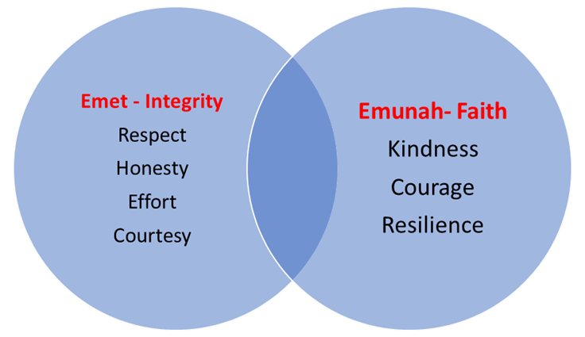
The King David High School is an Orthodox, Jewish Day School and its ethos is based on the teachings and traditions of the faith, together with the best in British values. Values are based on the school motto, Emet (Integrity) and Emunah (Faith).

You will be rewarded for displaying the values of Emet and Emunah as well as a wide variety of positive behaviours both in lessons and around school.

A variety of rewards will be given to students including verbal praise, recognition emails, praise in assembly, prizes, reward trips and special privileges.

To keep you safe and get the most from your learning in school there will be specific rules and instructions given to you throughout the day, however, the school has some simple expectations.
School expectations:

- Arrive on time
- Line up outside classrooms
- Listen attentively
- Sit up straight in chairs
- Put your hand up if you want to ask a question and wait for the teacher to invite you to speak
- Bring all necessary equipment to lessons
- Wear correct uniform
- Use respectful and courteous language
- Complete homework on time to a good standard
- Move around school in a calm and orderly fashion
- Interact positively with everyone in school

Teachers will focus on positive behaviour management, rewarding students who embody the values and behaviours expected of them. If you are not yet meeting these standards teachers will use a variety of interventions to encourage you to make a positive choice and correct your behaviour.

Remember there is always a way back; if you can demonstrate making a positive choice you can stop advancing along the pathway.

At each intervention, failure to make a positive choice will lead to the need for escalated interventions.

How do I make a positive choice?
Stop the identified behaviour | Avoid arguing back | Take ownership of your behaviour –recognise what you have done wrong | Recognise why you cannot continue to disrupt others | Apologise
If you make mistakes with your behaviour, there are a variety of responses based on the level of negative behaviour these are known as sanctions.

- Classroom Sanctions – for example teacher reminders, being kept behind at break, asked to attend booster/intervention.
- School Community Sanctions – for example, litter picking, lunch duty, assisting staff etc.
- Lunchtime Detention – 30 mins: issued automatically for a student being sent from a lesson or accumulated negative points.
- Tuesday and Wednesday Afterschool Detention – 40 mins: Issued for accumulation of negative points or repeated offences.
- Thursday After school Detention – 50 mins: Issued for failure to attend other sanctions, not responding to sanctions or single instances of serious negative behaviour.
- Sunday Morning Detention – 1-3 Hours: Issued for repeated failure to attend sanctions, not responding to sanctions or single instances of serious extreme negative behaviour.
In addition to the above, interventions and support methods such as placing a student on report or assigning a mentor will be considered.

Suspension
Instances of serious extreme negative behaviour, repeated and sustained negative behaviour or failure to respond/attend previous sanctions.
At this point, if the behaviour is ongoing, a student will be placed on an individual behaviour plan. If this fails to have a positive outcome a meeting with a Governors behaviour panel will be considered.
If previous sanctions and interventions have failed to improve behaviour or there are instances of extreme negative behaviour that warrant such a response, the school may consider Expulsion.

Restorative

In addition to sanctions, the school will employ a variety of restorative methods to help you learn from any mistakes and help you make positive choices in the future. These can be focused on classroom-based issues or negative interactions with peers.

Prohibited Items

The following items are prohibited from school and possession or supply of them will be dealt with by an appropriate sanction.

- knives, weapons or replica equivalents
- alcohol
- illegal drugs
- stolen items
- chewing gum
- tobacco, cigarette papers, vapes and lighters
- fireworks
- pornographic images
- food [except fruit and water]
- any items brought in to sell to other students

Toilet visits
Students without medical needs should not use the toilet during lessons.
This is to avoid you missing out on learning and help you develop responsibility for managing your needs at an appropriate time.

Mobile Phones

You may have your phone with you for the travel to and from school. However, the use of all phones is banned in years 7 to 11 and phones must be switched off during the school day. This includes before registration and at lunchtime. (Any student who needs to phone home may do so via the office). Sixth Form students are not permitted to use phones during lessons (unless specifically instructed by a teacher) or on corridors.
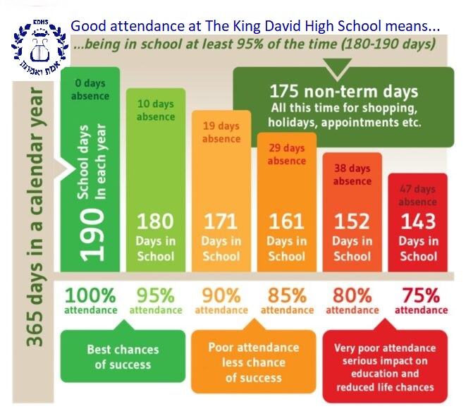
Attendance

Ensuring Good Attendance and Punctuality | Rewarding Good Attendance
Reminders  Attendance/Punctuality Report  Parental Meetings  Home visits  Catch up sessions  Sanctions | Personal success  Achievement points  In school rewards  Reward trips  Permission to attend school trips

Pupils with attendance of 95% gained an average of 2 levels higher in their GCSEs than those with attendance below 80%.

How to get the most from your learning

If you are attending every lesson and behaving positively you are setting yourself up for getting the most from each lesson.
But there are many more things you can do to get the most from your learning at KDHS.

In school:
- Be prepared for each day make sure you bring the correct equipment and books.
- Listen carefully and contribute your ideas and answers when asked.
- Ask for help but try to work on problems on your own at first – this will help you to learn.
- Listen and act on feedback.
- Understand that getting things wrong is part of the process of learning.

At home:
- Ensure you complete homework, giving it enough time and effort to help you learn from it.
- Read around your subjects and learn independently.
- Try to do things to deepen your understanding of your subjects, like watching documentaries, visiting museums, art galleries etc. Subject pages on the school website will give you some specific ideas.
Revising for exams
- Have a nice, well-lit place to work at home if possible (natural light is best).
- Turn your phone off and put it in another room.
- Aim to revise in 1 hour sessions with a break of 5 to 10 minutes.
- Try to avoid late nights: get into a routine and wind down before bed. Do a ‘digital detox’, staying off your phone and devices for an hour before you go to sleep.
- Try to exercise.
- Get someone (friend/parent etc.) to hold you accountable. Write down or tell them what you’re going to do that day.
- Reward yourself after a good revision session.

A good principle for revision is that ‘memory is the residue of thought’: We remember what we think about, so your revision must make you think.

These are some of the best revision strategies, as proven by educational research:
- Distributed practice - You’re best planning to revise stuff several times.
- Retrieval practice - Practice reviewing knowledge from memory (even 15 minute a day is great). Do it throughout the year, not just when you have exams or assessments.
- Elaboration -This is explaining material out loud. You can use a friend, a parent, or even explain it to yourself.
- Making flashcards and testing yourself - You can carry your flashcards around in case you have 5-10 minutes spare waiting for a bus, in a commercial break etc.
- Practice testing - This is one of the most effective techniques. Basically, you’re testing yourself, from memory, on what you need to know for the exams. It can be just quizzes or, particularly in the final run up to exams, past paper questions.
Think about the future
Throughout your time at KDHS staff will give you examples and advice around your future and careers. Ask questions and engage with information that can help you think about what you might want to do in the future. This website has careers profiles on it: www.prospects.ac.uk.

Informed Choices is a document produced by the Russell Group (traditional universities) on the subjects that they recommend for particular university degrees: https://www.informedchoices.ac.uk/.

Uniform and Personal Appearance Policy
The King David High School believes that our school uniform:
- Is practical and smart
- Promotes a sense of pride in the school
- Helps create a sense of community and belonging towards the school
- Promotes a sense of equality amongst peers
- Helps identify and represent the school
All pupils are required to wear the standard uniform and must conform to the following rules. Sanctions may be applied for failure to meet The King David High School standard.

All pupils
Please contact l.rose@kdhigh.co.uk if you need help to fund the uniform
Item | KDHS Standard | Not allowed
A navy blue blazer with the school badge. | Worn at all times to and from the school.  Worn at all times around the school.  School-awarded badges only | Taking it off without permission in the classroom  Must not be worn around the waist  Non-school badges/stickers
Navy blue V-necked knitted jumpers | Optional | Must not be worn around the waist. Sweatshirts are not permitted.
Black shoes in a flat sensible style | Plain black polishable only  Waterproof (not fabric)  Flat  Black sole | No contrasting colours eg. logos/ stripes/soles etc.  Patterned shoes  Shoes with heels  Boots  Pumps, sandals or canvas shoes
Boys uniform | Girls uniform
- School tie – to be worn to the neck at the correct length at all times.  - Plain grey school trousers to be worn at the waist.  - White school shirt  - Plain, dark coloured socks  - Kippot  - Tephillin (for assemblies) is encouraged following Bar Mitzvah | - Skirts must be loose fitting, navy blue with tick pleats front and back, to be worn at knee length at all times. (Skirts only available from School stockists).  - Navy blue stripe open neck blouse with reveres.  - Ankle socks or tights, either must be plain; navy blue or black
Boys’ P.E. | Girls’ P.E.
- Football boots & shin pads  - Indoor trainers (with soles which do not mark)  - Outdoor trainers  - Navy football socks  - Plain white polo shirt  - Navy shorts  - Badged navy shirt  - Navy blue swimming shorts  - Goggles (optional)  - Towel & toiletries. Spray deodorants are not allowed (shower facilities available) | - Indoor trainers (with soles which do not mark)  - Outdoor trainers  - White socks  - Plain white polo shirt  - Navy blue skorts/navy blue shorts  - School navy blue sports leggings (optional) only available from School stockists  - Plain navy blue swimming costume  - School swimming cap  - School Tracksuit/Sweatshirt (optional)  - Goggles (optional)  - Towel & toiletries. Spray deodorants are not allowed (shower facilities available)

Appearance
Sanctions may be applied for failure to meet The King David High School standard
Item | KDHS Standard |  | Not allowed
All uniform worn neatly and correctly | Clean and in good condition  shirts must be tucked into waistbands  sleeves rolled down  top buttons must be kept fastened  Skirts at the correct length. |  | Jumpers with frayed sleeves  Trousers with ripped hems.  Rolled-up skirts
Hairstyles | Natural in colour  Smart, neat and tidy |  | Extreme styles including:  Coloured/shaved patterns in hair or eyebrows  ‘Tip dying’ or unnatural or extreme coloured hair  Unnaturally coloured braids, accessories or extensions
Makeup | Completely free of visible make-up |  | Any type of visible make-up including;  Fake tan  Make- up bag/items  False eyelashes,
Nails | Natural, plain, acceptable length |  | Coloured nail varnish  False nails  Long Nails
Jewellery | Wristwatch only  Earring– single plain stud in lower lobe |  | Hooped, ’bling’ or dropped earrings  Facial piercings including nose piercings  Rings, bracelets and necklaces.
Equipment for School
All pupils must bring the following items to school
Item |  | KDHS Standard |  | Not allowed
Bag |  | All students are expected to carry their possessions in a suitable bag that fully closes  Sturdy and large enough to carry all school equipment and books. |  | Handbag style  Small over the shoulder fashion bags  Carrying belongings in blazer pockets
Pencil case |  | A number Black and/or blue pens  A green pen  A number of pencils  Ruler  Eraser  Scientific Calculator |  | Correction fluid  Laser pens

School Outfitters:
Monkhouse School - www.monkhouse.com
Mill Gate Shopping Centre, 86 The Rock, Bury 0161 476 7216
4-8 The Precinct, Cheadle Hulme SK8 5BE 0161 476 7216
PT’s Schoolwear - www.pts-schoolwear.co.uk
Market Hall, 14, Market Parade, Bury 0161 761 1365
7 New Road, Radcliffe M26 1LS 0161 723 0991

Uniform policy home school agreement
Pupils, who do not attend school in the correct uniform, will be spoken to by staff. School will be considerate and attempt to establish why a pupil may not be able to attend in the correct uniform. A pupil may be offered a replacement item to borrow if one is available; or, pupils may be given an opportunity to adhere to the correct uniform within a timeframe. However, in certain circumstances pupils may be sent home to correct their uniform or parents asked to bring in uniform items.
If a pupil repeatedly chooses not to wear the appropriate uniform and/or refuses to follow a reasonable request, such as borrowing uniform, then we will issue a consequence in line with our behaviour policy and expectations.
Having accepted a place at The King David High School, parents and carers are supporting us in reinforcing our values and high expectations.
Shoe examples:
Not Permitted
Permitted

Uniform examples:

2. Student Emails

Accessing Email:

- To access school emails externally go to: https://www.office.com/ and sign in with your school username ie username@kdhigh.co.uk and your school password. Alternatively, you can download Outlook for android/mac.

- Pupils can also access it through a link on the school website www.kdhs.org.uk.

- From this point, they should select Outlook Web Access from the left-hand pane to access their e-mails.

Giving Out E-Mail Addresses:

- All pupils have their own e-mail address. In almost all cases, the address is their full first name then surname:

name.surname@kdhigh.co.uk eg jonathan.smith@kdhigh.co.uk.

- In exceptional cases, where two or more pupils share the same name, pupils are distinguished by an extra number after their surname (from 1 onwards) eg jonathan.smith1@kdhigh.co.uk.

3. Edulink One

Edulink One brings together the things you need to manage daily school life. It is a complete engagement and management solution that supports parents, staff and students in and out of the classroom. It is accessible anywhere and on any device.

From the first week of term your son or daughter will be able to access Edulink to monitor behaviour, achievement, detentions, timetable and attendance. It will also allow monitoring of pupils’ homework. Teachers will begin to log homework for classes online, and this will appear on both parent and pupil Edulink logins. It will allow all pupils to have a digital record of what homework has been set. It also gives the option for teachers to add links and attachments to instructions. Additionally, pupils who have been absent will be able receive notifications of homework from their different subjects.

Information and login details are sent automatically at the beginning of term.

4. What to do if:

You are a victim of bullying - King David High School does not tolerate any form of bullying. You must report any incidents of physical or verbal bullying to your form tutor, or anyone you feel comfortable speaking to. Teachers cannot do anything about it unless you tell them!

You are late for school - Before going to your class, report to the office and sign your name in the late register. The school will then know you are on the premises in the event of a fire.

You miss your bus - Most importantly, don't panic. Let the school and your parents/carers know as soon as possible to make alternative arrangements to get you to or from school. Don't accept lifts from people you don't know!

You lose/forget your dinner money - Go to the school office. In most cases you will be given money that you must pay back as soon as possible.

You lose personal property - Report lost property to the school office to check this hasn't been handed in. Check the lost property area under the stairs and inform the school office. Keep expensive items at home or insure them if they must be taken to school.

You are ill - Let the school office know as soon as possible. For long term absences let the school office know by telephone. Any time off school that you have, needs to be covered by a note from your parents/carers. This must be handed to your form tutor when you return.

You cannot do your class work - Tell your teacher during the lesson; you might not be the only student struggling. Don't leave the problem to go away. Usually, unsolved problems lead to more difficulties later on. If you feel you cannot ask for help during the lesson, see the teacher at the end of class and arrange a convenient time to sort your work out. If you do not want to tell your teacher, tell your form teacher you are having difficulties in a particular lesson.

You cannot do your homework - Tell your teacher as soon as possible. Teachers are here to help you and will provide you with some assistance. If you cannot see your class teacher, then tell your form tutor. Never wait until your next lesson to tell your teacher if you cannot do your homework.

You have a problem with your teacher in class - Tell your form tutor as soon as possible. They will try and resolve the situation quickly. Don't put yourself in a position where you are disrupting classes by having disagreements with your teachers.

You forget your Computing password - See one of the Computing Staff or technicians. Don't use other people's user codes.

You have a problem with your computer in school - Tell your teacher. Don't try and repair hardware or software faults yourself.

You accidentally damage school property - Report any damage as quickly as possible. You will not be in trouble for accidents that occur. It is important we know about damage so that we can repair it as soon as possible. If you do witness vandalism, then report it, King David High School is your school as well as everybody else's.

Sickness - If a pupil feels unwell, they must report to the school office. One of the office staff will contact home. Pupils must not make direct contact with home. Should this happen, we would ask that the parent informs the school office. If a pupil needs medication, it must be kept in the school office. If your child has a medical condition, please inform the school. If they need to use the toilet frequently, they will be issued with a pass, as pupils are discouraged from leaving lessons.

The Lift - There are lifts available for pupils with injuries to use where necessary with parent notification.

You need someone to talk to in school - Should you want to talk about something that is troubling you, there are people in school who are there for you.

What can we talk about - We can talk about everything. Some of the topics are:
- Home life | - Physical abuse
- Feeling anxious | - Emotional/mental abuse
- Feeling down or depressed | - Sexual abuse
- Problems with eating | - Neglect
- Loss or bereavement | - Alcohol or drugs
- Self-esteem | - Sexuality
- Self-harm | - Transgender
- Suicidal thoughts | - Experiencing traumatic events
- Any thoughts or feelings that worry or concern you

To whom can you talk? - There are signs up around school identifying who to talk to for example your Form Tutor or Head of Year.

If you feel unsafe or concerned about another pupil being unsafe you can speak to the Safeguarding Team: P Watson, L Brown, D Pell, J Burberry and G Leventhall.
Who else can I talk to? - Kooth is a confidential, anonymous and free website where young people can go for help via Drop-in chats, booked 1:1 sessions and themed message forums. These can be accessed via kooth.com.

For confidential support with mental wellbeing, Early Break are available Mon - Sat 8 am – 8 pm on 0161 464 3679 www.earlybreak.co.uk.

Health For Teens is a school nurse service available for confidential advice on matters such as healthy eating, emotional health, relationships, smoking, bullying, self-harm, alcohol and drugs, anxiety and many other areas Telephone 07507 330205. Please click on the link for the website. www.healthforteens.co.uk.

Young Minds is a service providing support for parents whose children are suffering with Depression. www.youngminds.org.uk. Mind give advice and support to empower anyone experiencing a mental health. You can call them from 9 am – 6 pm Mon - Fri on 0300 123 3393 or text 86463. You can also email on info@mind.org.uk or visit their website by using the link: www.mind.org.uk

5. Instrumental and Vocal Tuition

The music department offers the following:

Individual and group lessons
- Woodwind – Flute, Clarinet, Bassoon, Oboe, Saxophone.
- Brass – Trumpet, Trombone, French Horn, Euphonium, Tenor Horn.
- Strings – Violin, Viola, Cello, Double Bass.
- Voice.
- Guitar – Acoustic Guitar, Electric Guitar, Bass Guitar.

Individual lessons only
- Piano.
- Percussion- Drum Kit.

Lessons
- Lessons last half an hour (both individual and group).
- Lessons are taught during the school day on a rotational basis to minimise repeated absence from a single subject lesson. Only GCSE and A-level students are given fixed lesson times.
- Timetables are displayed on the notice board in the music block from the beginning of each half term. Updates to times will be posted on the notice board.
- Lessons missed due to pupil absence or school trips will not be re-scheduled.
- Lessons missed due to staff absence will be re-scheduled if it would result in less than 30 lessons per year.
- Pupils may be offered individual lessons if there are not enough students to form a group.
- For further information on lessons, please contact Mr Rushworth on c.rushworth@kdhigh.co.uk.

Instruments
- Pupils must provide their own instrument for lessons and bring it each week.
- We have a small selection of instruments available to borrow from school (mainly for year 7 pupils), please contact the music department for further information.
- Pupils may be asked to return instruments if they have been borrowed for over one year if required for new starters.
- Pupils are responsible for the upkeep and repair of instruments that have been borrowed from school.
- Any repairs required for an instrument that has been returned in a damaged condition will be charged to parents.

Pupils must:
- Practice regularly and as their teacher advises.
- Check the music notice board at least weekly to check their lesson time.
- Excuse themselves at the beginning of school classes before their music lesson.
- Label their instrument cases and music folders.
- Store instruments in the locked facilities provided.
- Take their instrument home on the day of their lesson. The school cannot except responsibility for instruments left outside of normal school hours.
- Take part in at least one of the school ensembles. The school heavily subsidises lesson fees, so it is expected that all pupils contribute to the musical life of the school.

The fine print
- Parents must sign up to Music Lessons via ParentPay. Lessons will not be scheduled until parents have signed and paid for at least the first term of lessons. To cancel lessons a notice period of one half-term (approximately 6 weeks) is required. Please submit a request in writing to c.rushworth@kdhigh.co.uk otherwise full payment for the term will be incurred.
- All lessons will be offered on a first come-first-served basis. If an instrument is oversubscribed a waiting list will be started.
- Pupils may study up to two instruments in school, as long as academic work does not suffer.

Payment information
- The cost of group lessons is £100 per term and individual lessons is £140 per term.
- Fees are charged based on 30 lessons over the 38 weeks in school (averaged at 10 lessons per term).
- All payments must be made directly to the school using ParentPay.
- Payments must be made for the full term or the full academic year in advance.
- Payments for each term must be received in full at the beginning of each term in order for your child to continue with lessons, otherwise lessons may be stopped.
- Please contact Mrs Rose for further information on payments: l.rose@kdhigh.co.uk

6. Holiday List 2024/2025

 | Term Begins | School Closes (pm) | School Re-opens (am)
 |  |  | Monday 2nd September 2024
 |  |  | Years 7 return
 |  |  | Year 12 register
 |  |  | Tuesday 3rd September 2024
 |  |  | Whole school return
 | Rosh Hashana | Wednesday 2nd October | Monday 7th October
 | Succot | Tuesday 15th October | Monday 28th October
 | Winter Holiday | Thursday 19th December | Monday 6th January 2025
 | Half Term | Friday 14th February | Tuesday 25th February
 | Pesach | Tuesday 8th April | Tuesday 22nd April
 | Bank Holiday | Friday 2nd May | Tuesday 6th May
 | Half Term | Friday 23rd May | Wednesday 4th June
 | Teacher Training Day | Thursday 19th June | Monday 23rd June
 | Summer Holidays | Tuesday 22nd July
 | Please note the following days school is open for staff training only:
 | Thursday 29th August 2024
 | Friday 30th August 2024
 | Friday 20th December 2024
 | Monday 24th February 2025
 | Friday 20th June 2025
 | Early Closing Times
 | Rosh Hashana | Wednesday 2nd October |  | 1.30
 | Yom Kippur | Friday 11th October |  | 1.30
 | Succot | Tuesday 15th October |  | 1.30
 | Shabbat | Friday 1st November & Friday 8th November |  | 2.00
 | Shabbat | Friday 15th November to Friday 13th December |  | 1.30
 | Shabbat | Friday 10th January 2025 |  | 1.30
 | Shabbat | Friday 17th January & Friday 24th January |  | 2.00
 | Shabbat | Friday 31st January & Friday 7th February |  | 2.30
 | Shabbat | Friday 14th February |  | 3.00
 | Shabbat | Friday 28th February |  | 3.00
 | Purim | Friday 14th March |  | 1.00
 | School Closes | Tuesday 22nd July |  | 1.30
 | These arrangements are subject to alteration.
 | Please note that dates may differ with the Primary School.

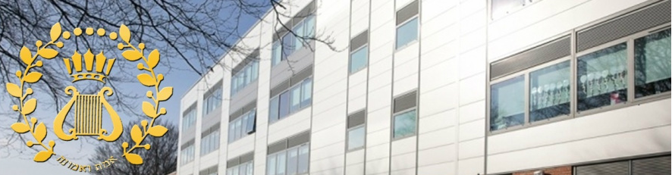

King David High School
English Department
Y6 Transition Booklet

Why is reading so important?

Reading for pleasure has been proven to significantly improve:

- Mental wellbeing. Reading can be a relaxing activity which is often a ‘pause for thought’ in your otherwise hectic day
- Your general knowledge, cultural awareness, self-knowledge and understanding of others
- Your reading and writing ability in all areas and subjects, including your range of vocabulary, text comprehension and grammar
- Self-confidence in de-coding, implementing, and generating ideas
As such we are committed, as a department and as a school, to trying to encourage reading across all year groups.

At parents’ evening the question we are most commonly asked as English teachers is: Is there anything else my child could be doing in order to help him/her improve in English? The answer, invariably but very simply, is: Read.

The benefits of reading extend far beyond English as a subject. Reading, for personal enjoyment has far-reaching and positive effects which are well-documented and supported by a great deal of research.

Perhaps the second most commonly asked question we get is: “How can we encourage reading and what should they be reading?” This is more difficult to answer. Reading for pleasure cannot be enforced – otherwise it becomes a chore. Our advice is always to read… anything! Read as widely as you possibly can and anything that interests you.

To help you find something that might appeal we have put together a list of contemporary fiction books which are (in the vast majority) written specifically for young people; we hope that you find something that excites and interests you. If you already have something on your ‘to be read’ list you are more than welcome to read other texts not on this list; in fact, we would welcome any of your recommendations.

This booklet also contains some optional activities that may encourage and support your reading over the summer.

Happy reading and we and can’t wait to hear all about your chosen books in September!

Summer Reading Bingo

Reading widely is proven to be one of the best ways to improve your work across all subjects. We get students arriving every year who just do not know where to start when it comes to choosing a new book to read.

Read a book that has been made into a movie. | Read a book that has been recommended by a friend or family member | Read a book from the school recommended reading list. | Read a book that is the first in a series of books.
Read a book with a colour in the title. | Read an autobiography. | Read a book that involves a natural catastrophe/ disaster. | Read a non-fiction book.
Read a book set in another country. | Read a book published in the last year. | Read a book that has won an award. | Read a book that is set in the past.
We have put together a challenge to help you set a target and get you reading more. The following grid challenges you to read books from a variety of genres, subjects, writers, and time periods.

When moving up to high school lots of students want to try and address any areas of reading and writing that they feel less confident with. The following table offers some suggestions about where you may find some useful websites and tasks that can help you to improve some of these skills.

If you want to improve your spelling:  The following websites contain a range of resources and interactive tasks that can help improve your spelling:  https://www.educationquizzes.com/11-plus/english/  https://uws.n-yorks.sch.uk/wp-content/uploads/2018/09/KS3-Spelling-Lists.pdf  https://wordwall.net/en-gb/community/ks3/spelling  https://www.bbc.co.uk/bitesize/topics/zbmv2sg  Reading is a brilliant way to improve your spelling and broaden your vocabulary.  Keep your own, personal dictionary. If you come across a word that interests you or that you don’t know; make a note of it. You could then use it to impress in your next piece of writing! | If you want to improve your punctuation and grammar:  The following websites contain a range of resources and interactive tasks to help improve your punctuation and grammar:  https://www.teachwire.net/news/7-of-the-best-online-grammar-games-for-ks2  https://www.bilsthorpeflyinghighacademy.co.uk/spag/  https://www.educationquizzes.com/11-plus/english/  https://www.educationquizzes.com/11-plus/english/  https://stphilips-chessington.org/wp-content/uploads/2020/03/Improving-Your-SPaG.pdf  Reading is one of the best ways of improving your punctuation and grammar too.
If you want to improve your comprehension skills:  https://www.educationquizzes.com/11-plus/english/  Read lots! The following websites have book lists that might interest you:  https://www.booktrust.org.uk/books-and-reading/our-recommendations/booklists/  https://schoolreadinglist.co.uk/  Try reading a book with either a friend or family member and then discuss what you have read.  Consider joining or setting up a book club to discuss what you are reading. There are some excellent resources online.  Visit local bookshops and browse the shelves. You may be surprised at what appeals to you. Also, staff are always more than welcome to offer recommendations.  Read different text types. You have more than just novels to choose from. You could try: articles, plays, diaries, autobiographies etc. | Set yourself a personal target for Year 7:  In year 7 I am looking forward to…  I would like to improve on…  To do this I am going to …

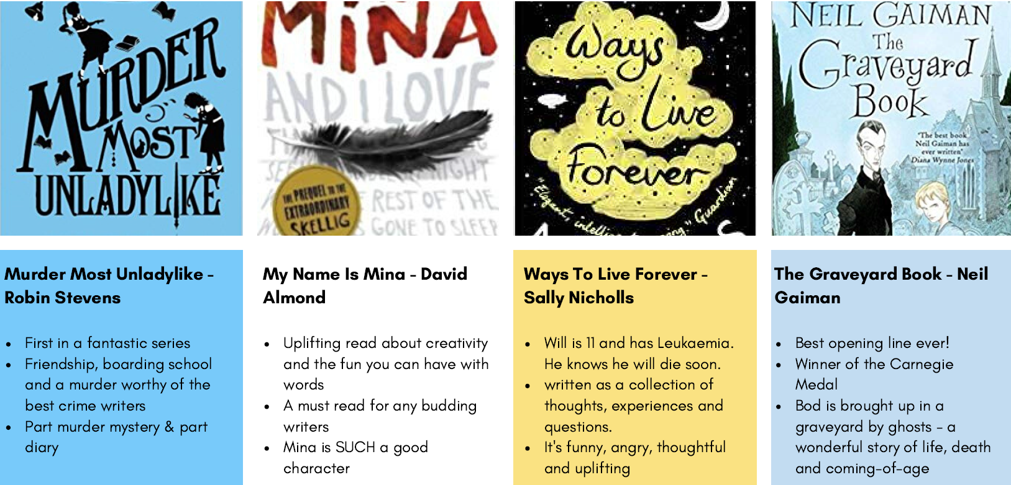
Some recommended reads…
Reading Journal
As you complete your reading for pleasure, use the following journal to help you keep track of what you have read and enjoyed.
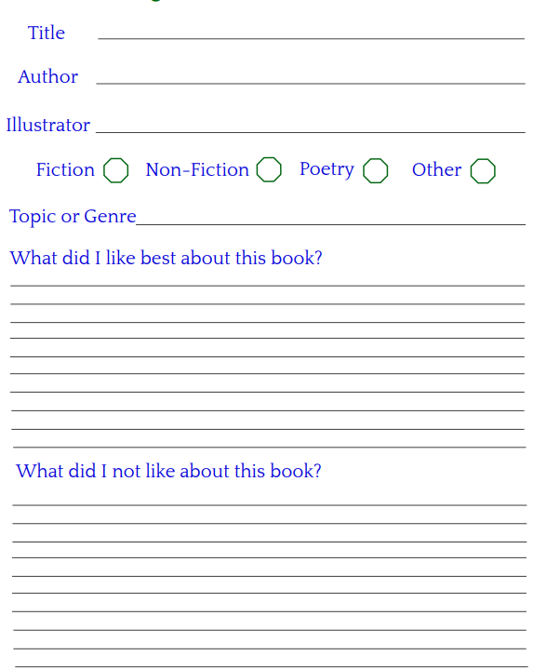

‘My Bookshelf’
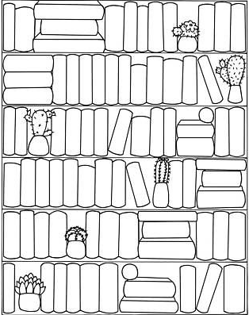
A lovely way to keep track of your reading is to keep a visual log. Colour in a book each time your finish a novel/article/short story etc. How colorful can you make your bookshelf by the end of the summer, term or even year?

